**ANALYSING HOUSING PRICES IN METROPOLITAN AREAS OF INDIA**





**ARUMUGHAM PALANIGURU ARTS AND SCIENCE COLLEGE FOR WOMEN**

**Affiliated to Madurai Kamaraj University**

**CHATRAPATTI**

**ANALYSING HOUSING PRICES IN METROPOLITAN AREAS OF INDIA**



Miniproject on

Analysing house prices in metropolitan areas of India

**BECHELOR OF SCIENCE**

**In**

**Mathematics**

**By**

**B. Aishwarya**

**A. Kali Devi**

**K. Pandidevi**

**G. Sangeetha**

**G. Subha nandhini**

**1.Introduction:**

**1.1 Overview**

In India there is a lack of scholarly work on real estate markets. However, the housing activity in the country, high already, is expected to further in the next few years, mainly because the government has already announced that it is committed to provide a house for all by 2022. Hence, this paper focuses upon residential property prices in metropolitan cities in India, specifically, on the study of fifteen metropolitan cities located at different parts of the country.

**1.2 Purpose:**

House prices are expected to help people who plan to buy a house so they can know the price range in the future, then they can plan their finance well. Metro cities in India are home to a large population and attract a large number of people from other regions seeking job opportunities, education, and better quality of life. The high demand for housing in these cities leads to a rise in property prices.

**2.Problem Definition & Design Thinking:**

**2.1 Empathy Map:**

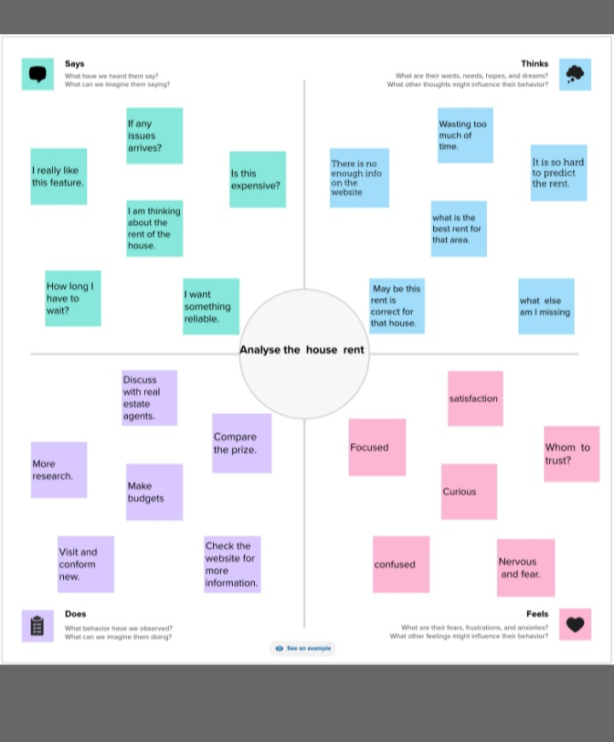

**2.2 Ideation & Brainstorming Map:**

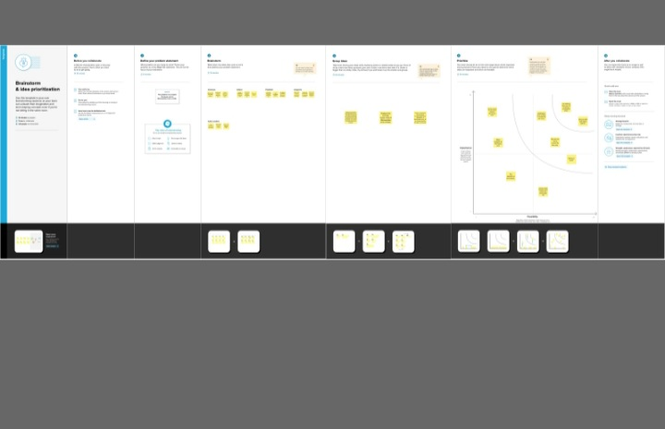

**3. Result:**



**DASHBOARD**

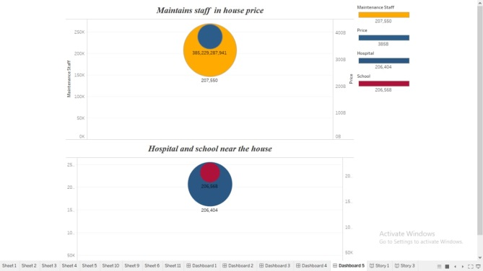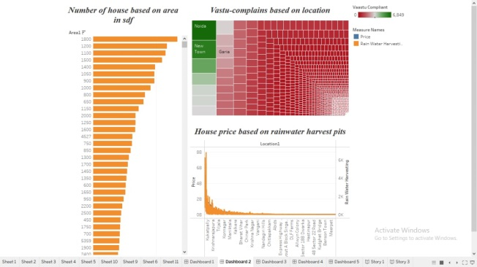

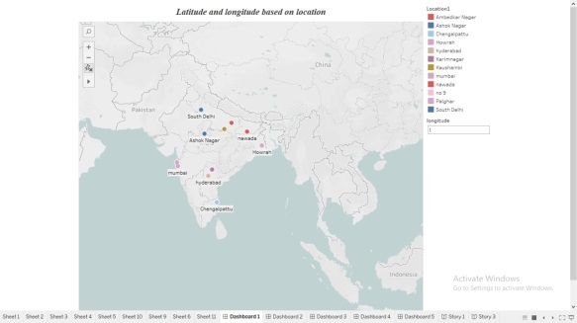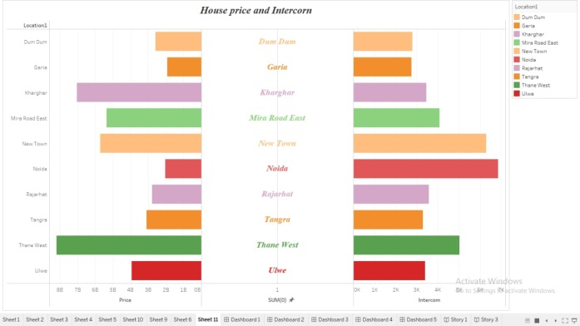

**STORY**

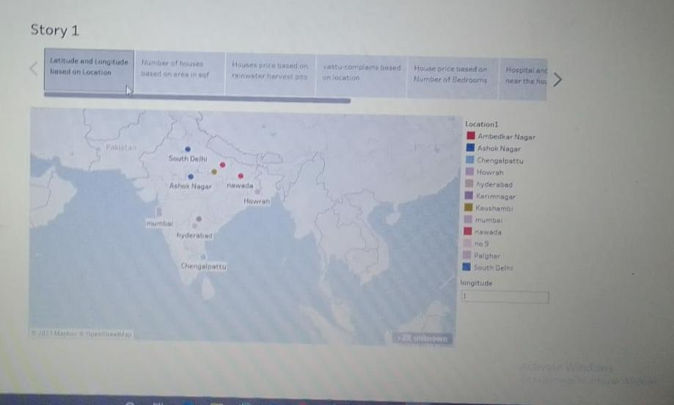

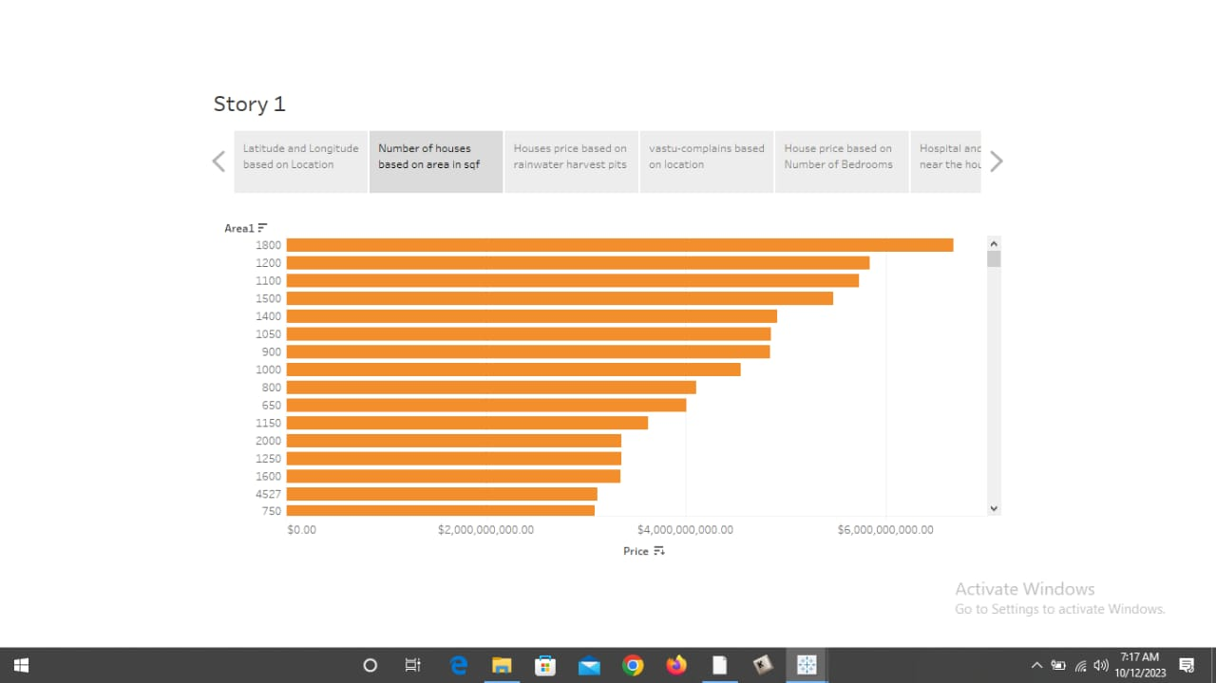

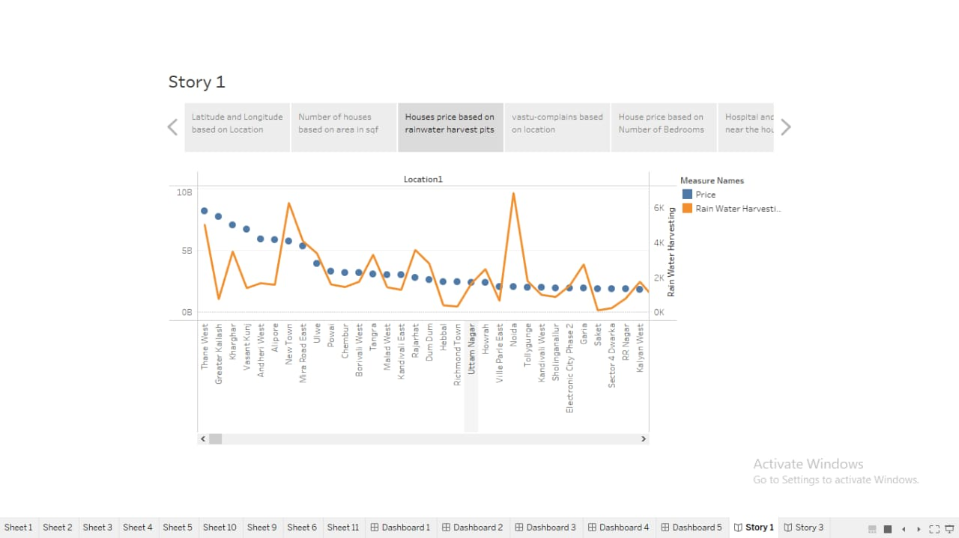

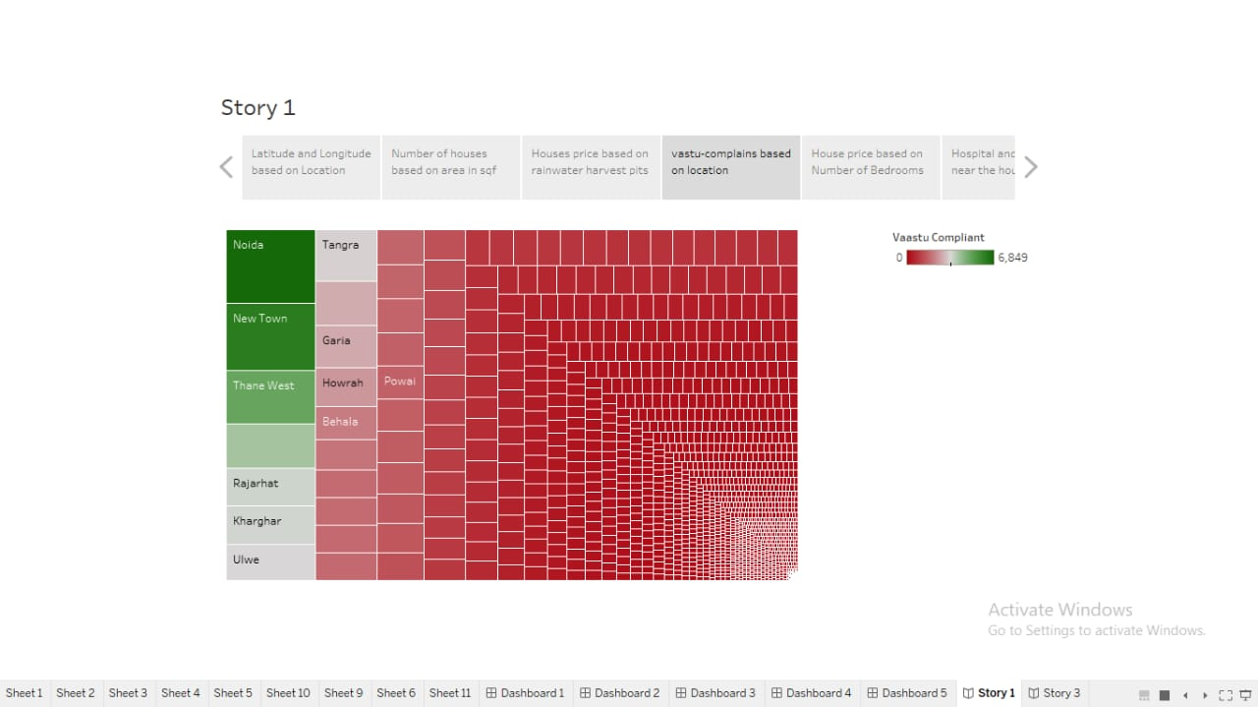

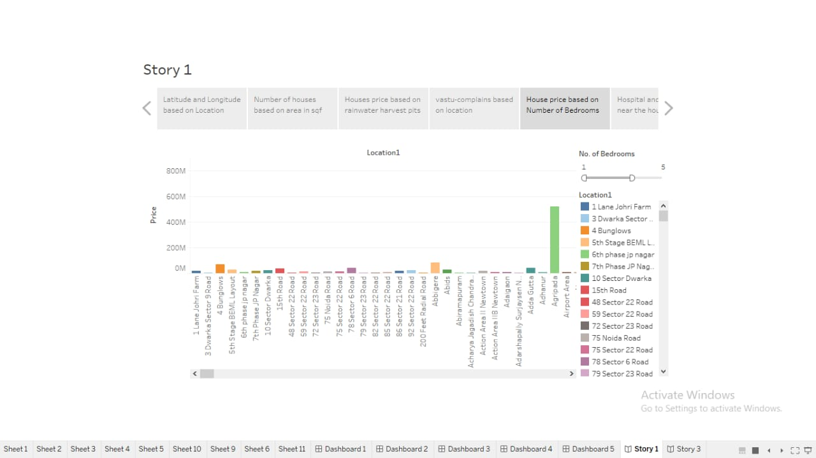

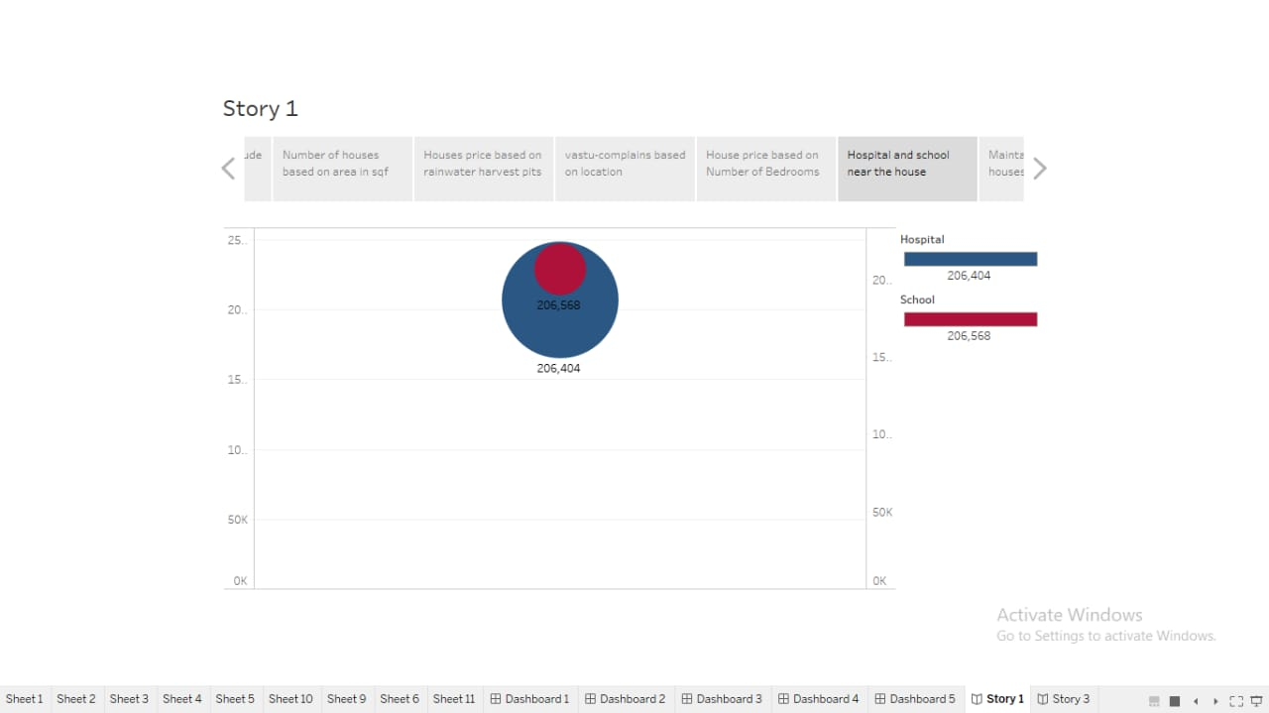

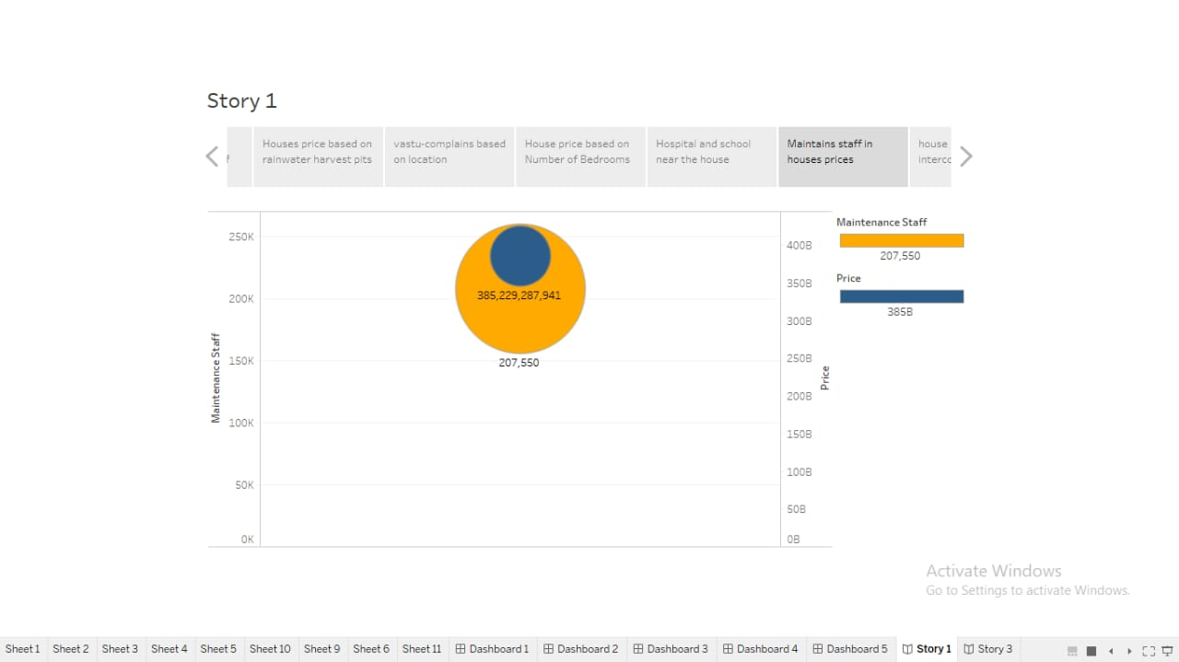

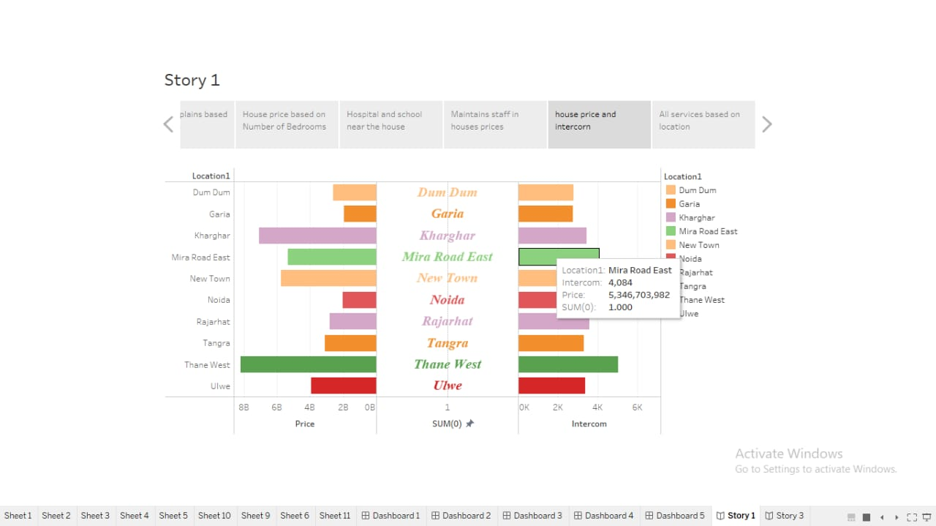

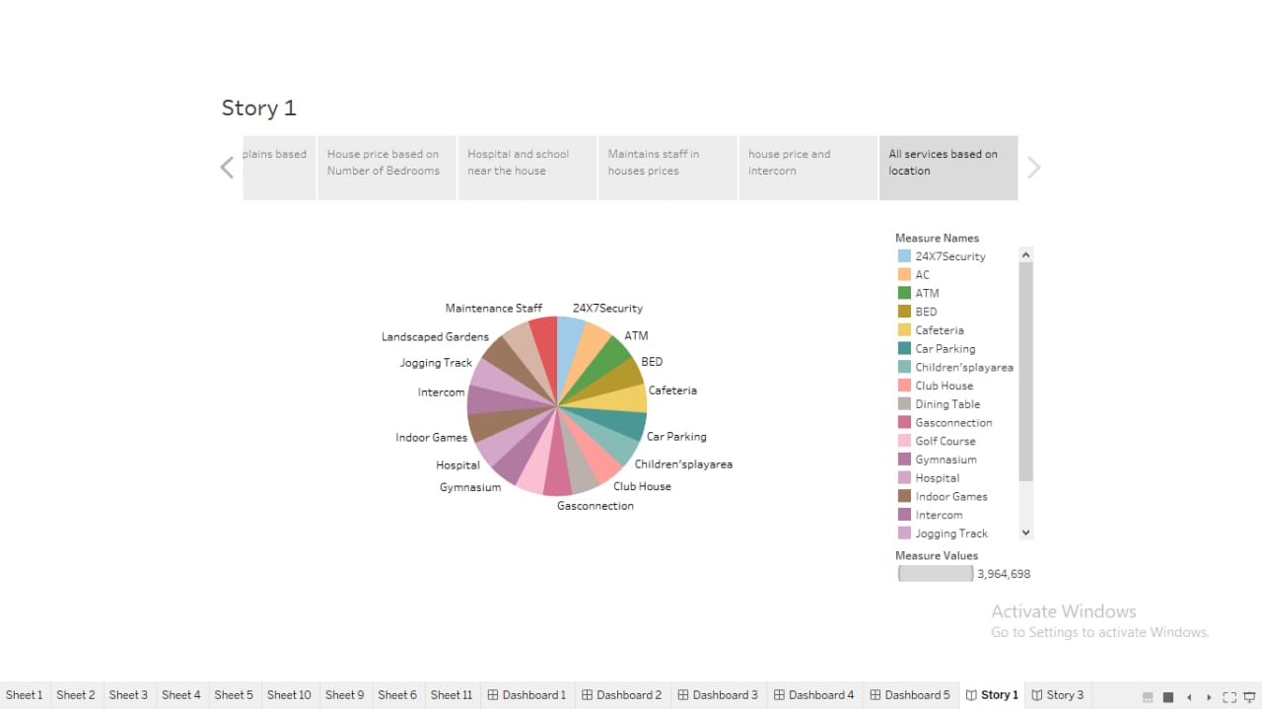

**ABOUT**

House prices are an important determinant of household sector’s gross and net wealth and thereby of consumption and savings. In many countries, including India, house property is the household’s largest asset, and price developments in housing markets can impact growth directly but mainly through credit channel since real estate can serve as collateral for consumer borrowing (Kiyotaki and Moore, 1997; and Bernanke and Gilchrist, 1999). Furthermore, housing cycles can influence the economic activity through wealth effects on consumption and private residential investments mainly due to changes in profitability and the impact on employment and demand in property related sectors.

1. **ADVANTAGES & DISADVANTAGES:**

**ADVANTAGES:**

* Budget houses are usually available within a low budget. For example, while a 2BHK apartment from a high profile builder may cost builder may cost Rs. 70 lakh, a budget house from a local builder may cost about Rs. 45-50 lakh. Hence, it is well within the affordability range of most home buyers.
* These houses have huge demand form the middle income group. As such, investors who want to sell their properly may witness more liquidity, as these properties sell faster. Moreover, since the demand is high, these properties also have the potential for a good appreciation in a shorter period compared to the high priced properties.
* Most times, budget homes are available in the peripheral areas, which still need to witness growth. However, when these areas grow, the percentage of appreciation is higher. For example, karjat, an area in the outskirts if Navi Mumbai witnessed an appreciation of 6 percent within the first three quarters in 20i3, while walkeshwar, an area in south Mumbai witnessed just an appreciation of 3.6 percent during the same period.
* If you are buying a house for the first time taking a home loan, you have a tax advantage.According to the Union budget in 20i3, first time home buyers are allowed an additional tax deduction of Rs. I lakh on loan interest for hosing loans up to Rs. 25 lakh, provided that the house value does not exceed Rs. 40 lakh. This means that, people buying budget houses using home loans have an advantage of walver of RS. I lakh on home loan interests.

**DISADVANTAGES:**

While there are certain advantages of budget houses, there are also disadvantages of budget houses. Some of them are

* Most of the budget houses are in the outskirt is which lack good connectivity and social infrastructure. These may create problems for many home buyers. Also, if the house need some repair and maintenance, it may prove a hard time to find a solution.
* Budget houses also usually lack the kind od amenities a big budget builder may provide such as swimming pool, club house or even the quality of house fittings such as door and bathroom fittings among others.
* One may buy a budget house from the point of selling it at a higher price later. However, finding a buyer for a house in the remote areas is not easy. While the return is good on paper, it may not be attractive in reality. The rental yield in such properties with better social infrastructure and good amenities.
* Small budget houses definitely prove advantages if you are an end user and alright with compromising on certain things such as connectivity, social amenities and quality. However, you may also went to consider the disadvantages a budget house brings with it, before going for such a house**.**

**Conclusion:**

In this project we analyzes house prices in five metropolitan areas in India, namely Delhi, Mumbai, Bengaluru, Kolkata, Chennai. This implies that the house prices in the different areas operate as segmented independent local areas. Therefore, house prices in one location in India cannot impose a competitive constraint on house prices in other location, and as such a home owner can freely set the price of his house**.**



Angels

Team leader

b.aishwarya

team members

a. kali devi

k. pandidevi

g. sangeetha

g. subha nandhini